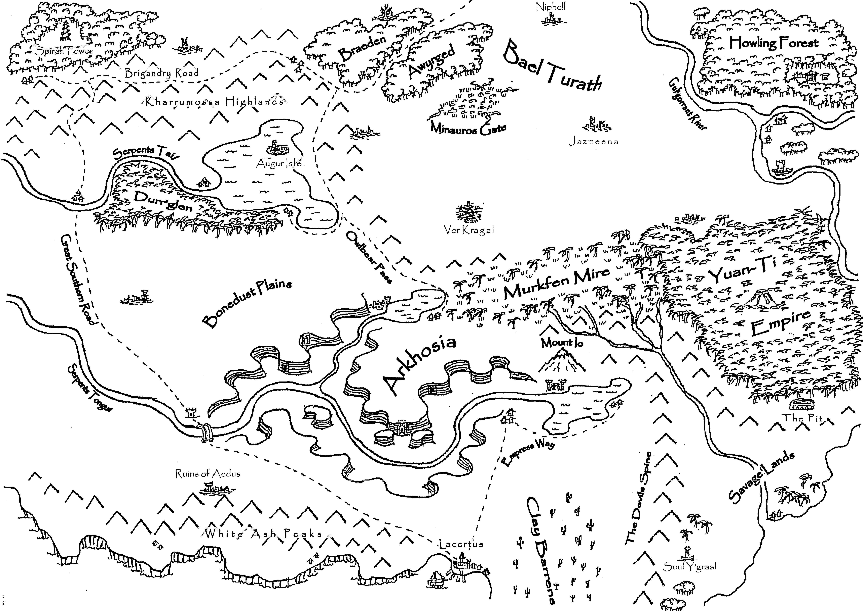
The Eastern Empires through the eyes of Cleyghorn the Traveller

