III. Management of the layers and of the opacity,

- At this level, the result is too opaque. As I always work with the continents on a white background and the oceans on a black [picture n°1], I just have to lower the opacity of the layers which contains the ground colours. By lowering the opacity of the “ground” layer to 75% and then to 50%, you obtain the tints of a more clear night [pictures n°4, 5 and 6]. You can also try to lower the opacity of your mountain layer, hill layer, forest layer and of all the ones you want to reach a better result. Instead of lowering the opacity of these layers, you can also have a similar result by putting the layers mode to lighten or to overlay.
- Take your time to adjust at your convenience following that you wish a landscape rather clear (lunar night) or rather dark (black night).
  - N.B. The point quoted in introduction in the part "Before beginning" is necessary for this step. If you don’t have the black and white layer, you can create it now and slide it under the pile of layers.
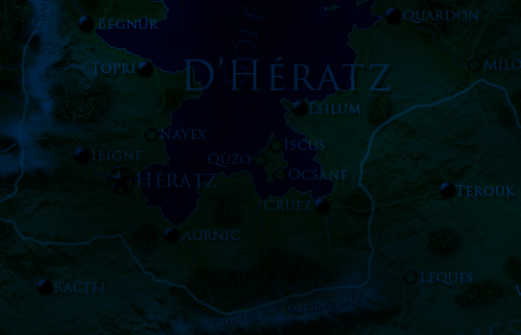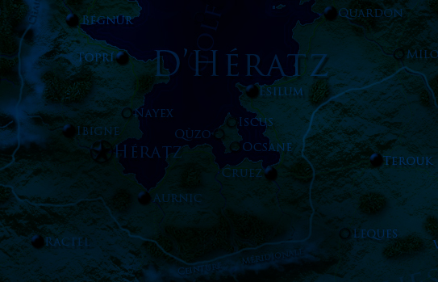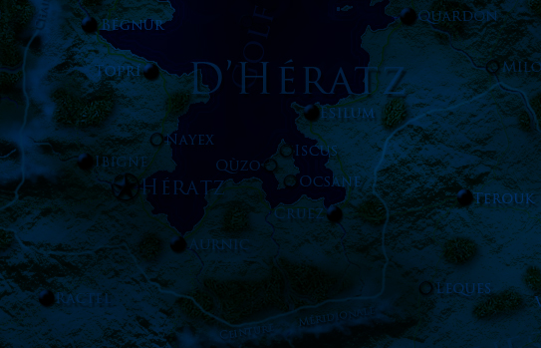
4. 5. 6.
Opacité : 100% 75% 50%

- When you are satisfied of the night-tint obtained, it’s time for you to hide the layers which you do not want to let visible anymore (for example, I hid the names of places, the borders, the icones) to let visible only the natural elements (and the ones you wish to let visible) [picture n°7].
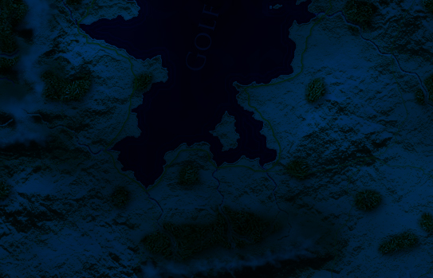7.

- Once it’s made, take time to manage the layers that you decided to let visible: place those which you wish to have more visible above the layer "night" (for example the title of the map, the legend, the signature, etc.) in order that it stays readable.
- If necessary, lower the opacity of these layers so that they would be better adapted to the new night-tint of the map (for example, for the map of the Pays de Tía, you can observe that I decreased the opacity of the scale, the signature, the title, etc. with regard to the diurnal view of the Pays de Tía in order it doesn’t be too clear on the night-tint) [pictures visible at the Cartographers’ Guild forum].



IV. The lights layers,

- Create a new layer just above the “night” layer and name it “lights”.
- Lower its opacity (in my examples, I decreased it at 27%)
- Choose as foreground colour a yellow or a very clear beige (in my examples I chose a yellow a bit sanded e9b95c).
- Take the pencil tool with the finest diameter (1 px).
- Now, the "longest" step: draw the points representing the lights of the cities, the roads, etc. by agglutinating them more in the most populated places (in and around cities, towards roads, coasts, rivers, etc.) [picture n°8].
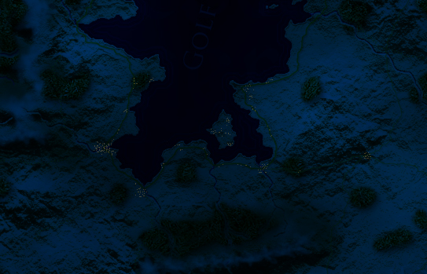8.

- Create once more a layer named “lights bis” or “lights 2” for example.
- Repeat the same operation but, this time, let the opacity of the layer at 100%.
Draw the new bright points rather in the heart of big cities or villages or at the important crossings in a goal of realism. [picture n°9].

- This layer allows to make more visible the important centers of the represented zone. It can also be the opportunity to make more visible a sanctuary, a temple or quite other special place which was not so visible on the "diurnal" map of the zone.
  - N.B. It’s possible to create other layers for the lights with opacity values intermediary (50% or 75% for example) following your needs.
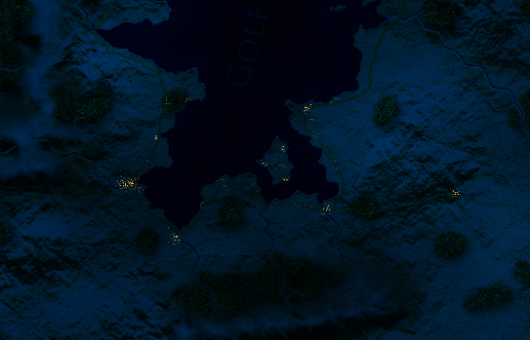9.

