Couple of things before we start:

1) Im not the best at explaining things. I know how I do them, but it may confuse you a little
2) This is mostly to remind me of how I made my volcano.
3) You don’t always have to use the same settings as me, I just put the ones that work best for me.
4) I am making this from scratch. I am not making this on my old continent, cause I don’t have enough room.
5) Im assuming that you don’t have a continent already made. If you do, then skip step 1.
6)

There are different ways you can make a volcano, but I prefer making it like this:

1. Assuming you read my Creating a Continent in GIMP tutorial, you should know how to make the mountains. If you do then good, cause that gives you some experience. Okay then, assuming you don’t have a continent or anything, and that your making this from scratch, then create a new image, and delete the background layer. Now create a new layer, and name it Sand To Rock. Change the foreground color to a sandish color, I use d7cc8f, and change the background color to black. Now using the blend/gradient tool, click at the bottom of your picture, somewhere off the image, and then drag to up above the image. You can do it from corner to corner or side to side if you like.

2. Create a new layer and name it Height Map. Now we need some clouds for our height map. Heres how we do it:

1) Go under Filters: Render: Clouds: Solid noise.
2) If you want small mountains, then have the Detail set to 15, and X/Y set anywhere from 10-16. 16 gives you the smallest mountains. If you want big mountains, then have detail set to 15, and X/Y set anywhere from 4-10, 4 being the biggest. I prefer 8 myself for large mountains. Also, you can use whatever seed you want, just don’t check turbulent or any of those things, and be sure to remember what seed you used. I suggest if you want a really random seed, then check the randomize box, and then uncheck it, that way next time you wont have a completely different seed.
3) Now with the height map layer still selected, do Filters: Render: Clouds: Difference Clouds. You can mess around with the settings if you like, but be sure to use the same seed as your solid noise seed, and don’t check any of the boxes. I find that a detail of 7 and an X/Y of 4 works well.

You should now have your height map. Use a 19 fuzzy brush eraser with scale set to 10 to erase the areas where you don’t want mountains. If you have water on your map, then erase the height map away from the water.

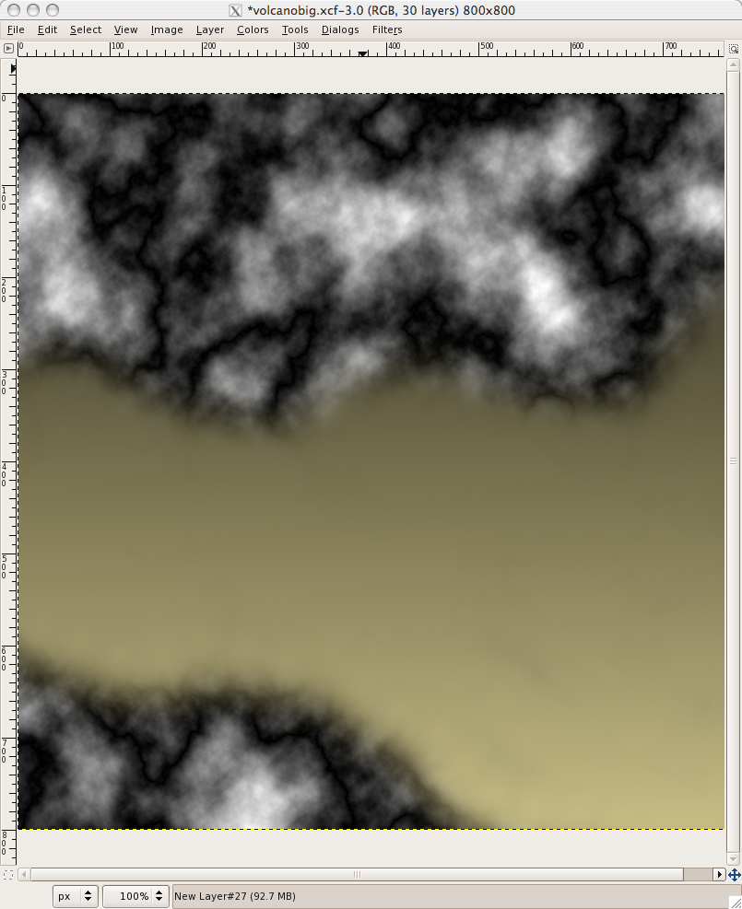

3. Now you need a "funnel". Create a new layer above the height map layer, and don’t name it. BE SURE YOU HAVE IT SELECTED DURING THIS ENTIRE STEP. Using a paintbrush that is NOT fuzzy, make a black spot on where you want your funnel. Be sure to do this on WHITE PARTS ONLY, the whiter the better. Depending on wether your mountains are big or small, use a different sized brush for this. If you have a big mountain, then use a 19 brush with scale set up to 1-10. If they are small, then use one with a scale from 1-0.01. I use a scale of 2. Now once you've done that, Gaussian blur the layer you did it to. Anywhere from 1-50, the bigger the circle, the large the Gaussian blur. Be sure you don’t give it to much Gaussian blur.

4. Merge it down to the height map layer. Hide your height map layer now. Select the land layer that your bump mapping this to, and then do Filters: Map: Bump Map. Make sure the bump map is set to the height map layer, and do the rest of the settings as follows:

Map Type: Linear or Sinusoidal
Compensate for darkening checked
Azimuth: Any, but I prefer either 0 or 135
Elevation: 45
Depth: 25
X/Y Offset: 0
Waterlevel: Any
Ambient: Anywhere from 0-100

If you do the linear map type, you will end up with mountains that have no breaks, even the slightest, but that has little crevasses that are good for the rivers of lava, while sinusoidal in my opinion looks more natural and leaves some flatter areas for lava lakes. Also, try inverting the bump map. It sometimes looks good, other times it gives huge dents in the land. And play around with the waterlevel, sometimes it looks good all the way up, sometimes it looks good all the way down
Sinusoidal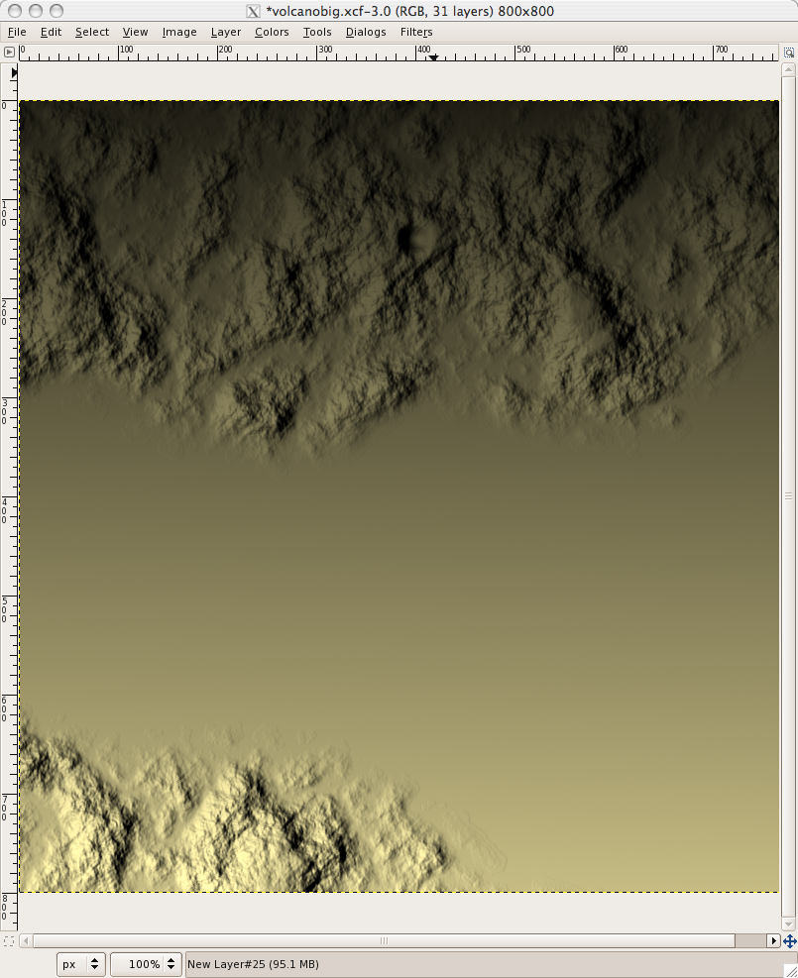

Linear: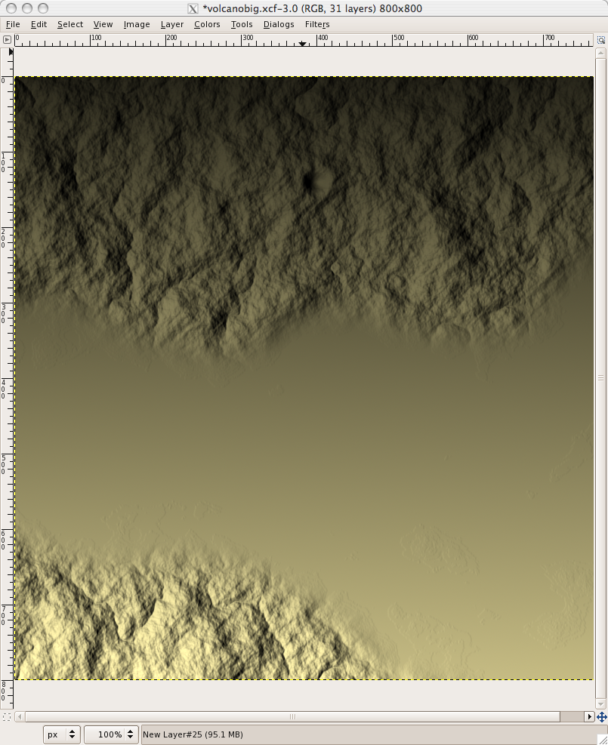

5. Next, we create the lava, and Im gonna spit this step into 3 parts:

Part 1, Funnel Lava: This step is the easiest in my opinion. Create a new layer, and call it Lava 1. Using a Circle paintbrush that is smaller than your volcano funnel, and an orange-ish color (I use ae7300), paint basically a kinda "spot" in the funnel. Now do Layers: Transparency: Alpha to Selection, then Select: Invert. Create a new layer now, and name it Red Lava. Fill the inverted alpha to selection with a dark red/maroon color, something like 6f0000. Now select none, and apply a Gaussian blur. Now do the same alpha to selection invert thing I had u do just a moment ago, and then with the red lava layer selected, do Edit: Clear. You should now have a nice Red/Orange funnel. Also, put the maroon color you used as the background color right now, and the orange color as the foreground color. If you want also, you can change the Lava 1 layers opacity to 50%.

Part 2, River Lava/Lava Lakes: Create a new layer and name it Lava 2. Zoom in to 200-800%, and with a fuzzy 3 paintbrush with the foreground color that orange color you had used, draw your lava rivers. Try to draw them so that they flow with the land and such. So if the land suddenly goes flat, then basically stop. Also, start at the funnel when you start drawing the rivers. Heres an example of what I mean when I say "flow with the land":

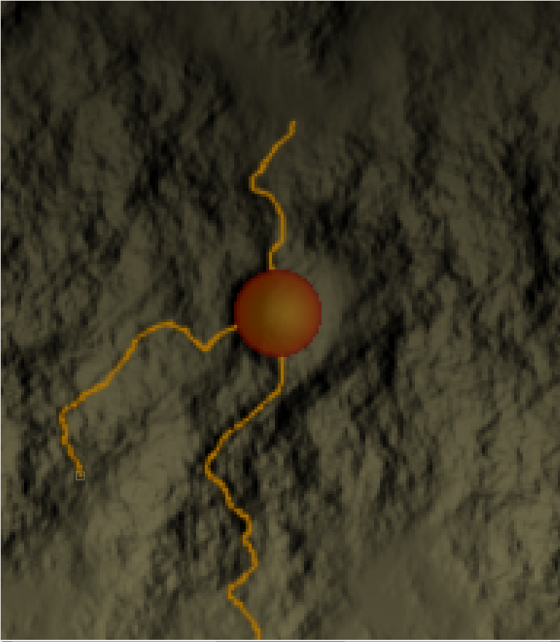

Once you have finished the rivers, then do Layer: Transparency: Alpha to selection, then Select: Invert. Create a new layer, and name it River Red. Fill the inverted alpha to selection with the same color red as you used before for the funnel red. Select: None, and apply a Gaussian blur. Don’t make it to much, somewhere between 1 and 5.

Now create a new layer and call it Lava Lakes. Where ever you stopped drawing the rivers because of a flat area, add a lake. Now do the same thing to it for redness as before, but increase the Gaussian blur a bit, like by 1-5.

Part 3, Making the funnel and the rivers blend:

If you haven’t noticed, the funnel and rivers probably don’t blend to well. Heres how we'll fix it:

Create a new layer right below the funnel and funnel red layers. Name it Blend. Get an airbrush tool, and choose a large fuzzy brush. The larger the funnel, the larger the brush. The brush has to cover the funnel and some. Set the rate to 150 and pressure to 10. Click the lava rivers layer and do Layer: Transparency: Alpha to selection. Select the blend layer again.Now position the brush so that the center of it is about directly over the funnel. Click a couple of times (1-20 times). Select: None. It should now have blended nicely ☺

If you need to, do the same thing or close to it near the lakes, but with a smaller brush.

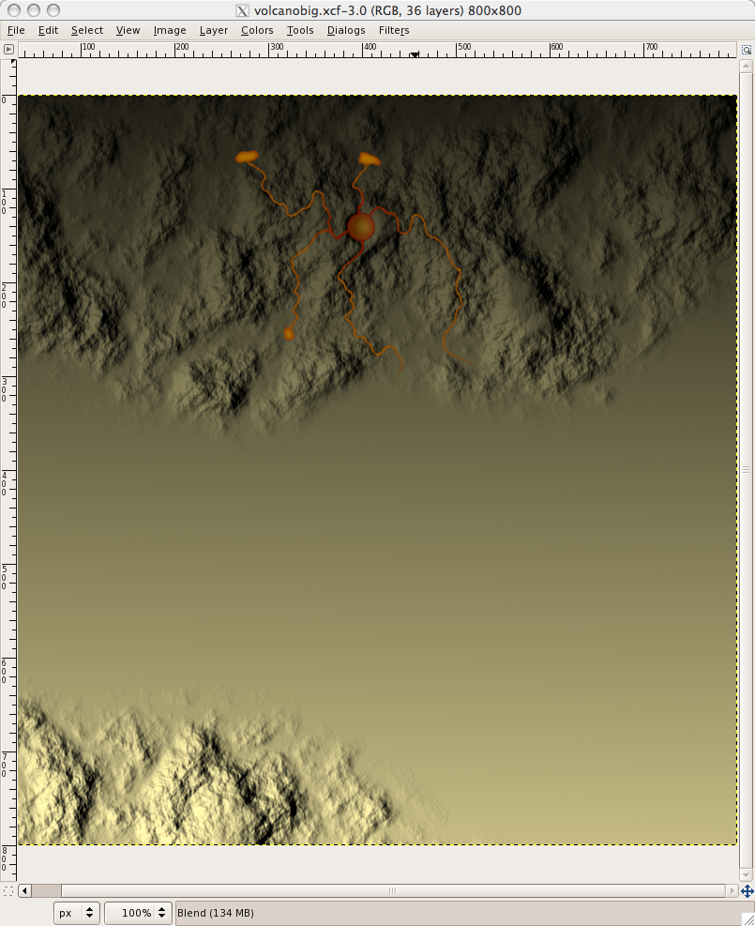

6. Now we just have 2 things left. First of all, lets color the mountains. Create a new layer directly above the land layer, and use a dark red, dark grey, dark brown, dark red-brown, or black color with either a fuzzy 19 paintbrush with jitter set to five, or using a large airbrush with rate set to 100. Create a new layer for each color you do, and mess around with the layer mode. The layer modes that work best for me are:

Darken Only
Color
Hue
Overlay
Normal (works well for aibrushes).

If you do any paintbrushes with 5 jitter, then to make it smoother for that color, try adding a Gaussian blur

Now this is optional. If you want smoke/steam then do it, if not, your done! I must warn you tho, if you do want smoke/steam, it’s a little tricky Heres how we make the smoke/steam:

Create a new layer above all the rest
Using a circle paintbrush that smaller (if only slightly) then the funnel, and with color set to either grey or white, whichever you prefer, start in the funnel, and draw 2 curvy lines that go in the same direction. Connect them with a curvy line, and then take a fuzzy 19 eraser with scale set to 10 around it, so that the edges around the funnel are only slightly erased, and the edges farther away are erased more. Then take a scale 10 fuzzy 3 eraser around the edges to blur it a little, then apply a Gaussian blur.

Sorry if that parts confusing! Heres what I now have that Im finished:

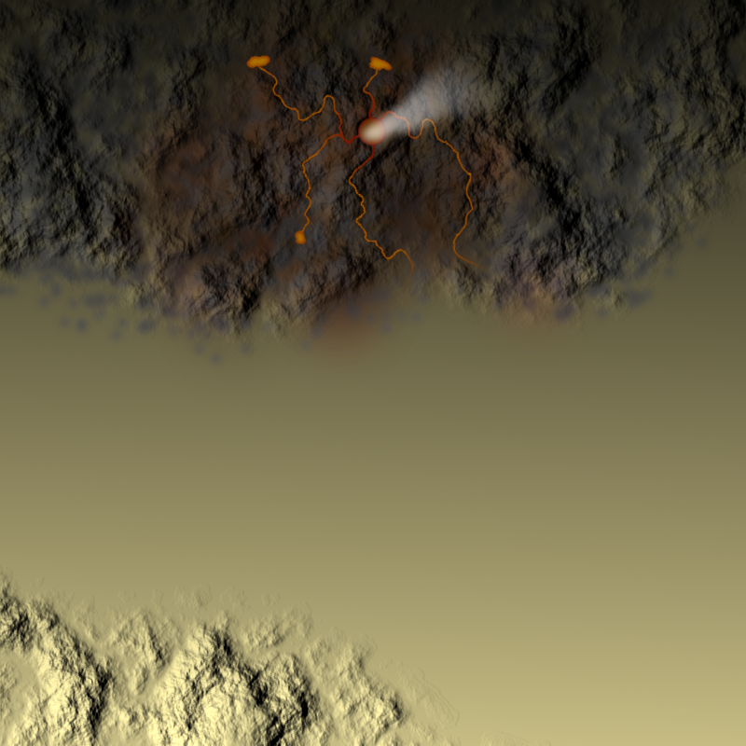

TIPS:

Lava Rivers: If you don’t want to have them end in lakes, then you don’t have to. You can try to have them fade out if you want

Smoke: If you want, you can try using a fuzzy airbrush for this, drawing more at the funnel then the farther away parts of the smoke

